Zebra rFid Mobile app & Sato printer graphical user interface

Installation and Usage Guide

PRDCSG

06/12/2023

Table of Contents

1. Zebra RFID Mobile App 2

1.1. Zebra RFID Mobile App Installation 2

1.1.1. Installation Requirements 2

1.1.2. Download 2

1.2. Zebra RFID Mobile App Usage Guide 3

1.2.1. Features 3

1.2.2. Troubleshooting 6

2. SATO Printer Graphical User Interface 8

2.1. SATO Printer Graphical User Interface Installation 8

2.1.1. Installation Requirements 8

2.1.2. Download 8

2.2. SATO Printer Graphical User Interface Usage Guide 8

2.2.1. Features 8

3. References 10

# Zebra RFID Mobile App

Zebra RFID Mobile App aims to help speed up the process of asset tracking by providing real-time information on tag detection status and the RSSI (Received Signal Strength Indicator) of the tag. Users can input a unique work ID, and the app generates an encoded string that serves as an identifier for the tags. Overall, this facilitates quick and accurate identification of assets, streamlining the overall asset tracking process.

## Zebra RFID Mobile App Installation

### Installation Requirements

#### Supported Operating Systems:

* Android 10 and later for RFD40XX

### Download

1. On Android device, navigate to 'Apps' > 'Settings' > 'Security', enable 'Unknown Sources', then tap 'OK' to agree to enable this setting. This will allow the installation of third party apps and standalone APKs.
2. Download the APK file (‘app-release.apk’ under app/release folder) to your PC. You can simply save it to the desktop.
3. Connect your Android device to the PC using a USB cable. At this point, it will ask you if you want to charge your device or connect it as a 'Media device', select 'Media device'.
4. Navigate to the APK file on the PC and copy the APK file into a folder in your Android device. It can be stored in the internal storage or the external storage of your Android device.
5. After that, we need to open the Android device’s file manager to locate the APK. It’s usually called My Files, or File Browser, and you’ll typically find it in the app drawer.

Note: If there is no file manager app installed yet, you can download a free file manager app from the Play Store, such as ES File Explorer.

1. On the Android device, tap on the APK file you just copied, it will ask if you want to install the app, just confirm and proceed, once it finished, tap 'Done' button and the new app is ready to use!

## Zebra RFID Mobile App Usage Guide

### Features

#### Locate a Tag

1. Insert a work id into the work id text box. (Figure 1.a.)
2. Click on ‘FIND’ button. (Figure 1.a.)
3. Press on the handlheld trigger (Figure 2) to initiate the scan.
4. Once a tag that contains the work id is detected, the RSSI (Received Signal Strength Indicator) will appear on the screen.
5. If not detected in the vicinity, a red cross icon will show and a “Tag not detected” message will appear. (Figure 1.b)

Figure 1.a. Main Page

Figure 1.b. Main Page when tag not detected

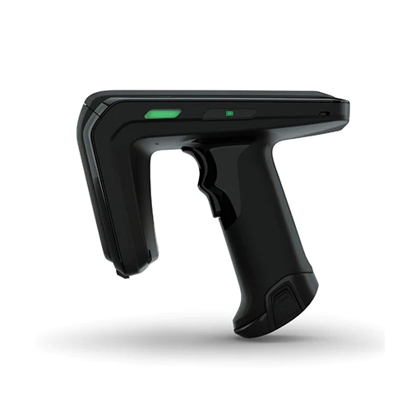

Figure 2: Handheld trigger of the RFD40 sensor

#### View History

1. Click on the history icon on the top navigation bar. (Figure 3)

Figure 3. Top navigation bar of main page

#### Clear History

1. Click on the history icon on the top navigation bar. (Figure 3)
2. Click on “Clear History” button to clear data.(Figure 4)

Figure 4. History Page

### Troubleshooting

#### 1.2.2.1. Reader connected, but scan not working (i.e. Decode LED not emitting green light)

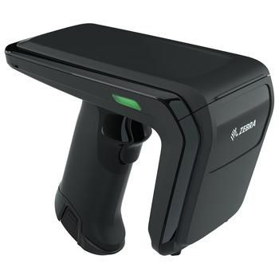

Figure 5: Zebra RFD40 Scanner Decode LED

1. Check the battery status of the RFID scanner by checking the battery status LED.
   1. Green indicates sufficient battery.
   2. Orange indicates a moderate amount of battery.
   3. Red indicates low battery.
   4. Blank indicates no battery.

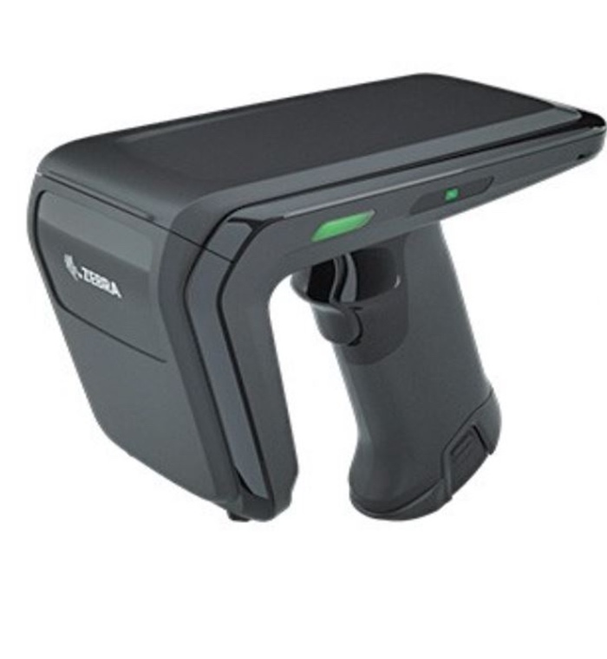

Figure 6: Zebra RFD40 Scanner Battery Status LED

1. When the battery is green, but it is still not working.

Solution 1: Exit the application and re-enter.

Solution 2: Reinsert the battery of the sensor.

# SATO Printer Graphical User Interface

SATO Printer Graphical User Interface helps to streamline the asset tracking process by allowing users to input a work ID, print and write the encoded string into the tag. This feature eliminates the need to know its unique tag ID, improving the efficiency of the process. By simplifying the identification process, the SATO Printer GUI contributes to an expedited asset tracking experience.

## SATO Printer Graphical User Interface Installation

### Installation Requirements

#### Supported Operating Systems:

* Windows 7
* Windows 8 and 8.1
* Windows 10

### Download

1. Launch the SATONETGUISetup.msi file under SATONETGUISetup/Release folder to initiate the installation process.
2. Press “Install” once installation prompt appears.

## SATO Printer Graphical User Interface Usage Guide

### Features

#### Printing RFID Tag

1. Ensure that the SATO Printer USB cable is connected to the computer.
2. Insert the work id into the work id textbox and press the enter key on the keyboard.

#### Clear Work ID Insert text field

1. Click on the “Clear” button to clear the text on the work id text input field.

Figure 7. SATO Printer GUI

# References

atlasRFIDstore. *Zebra RFD40 Standard UHF RFID Sled*, cdn11.bigcommerce.com/s-ka7ofex/images/stencil/1280x1280/products/3570/15125/Zebra_RFD40_Standard_UHF_RFID_Sled__21363.1625969937.jpg?c=2.

The Barcode Warehouse Limited. *Zebra RFD40 UHF RFID Standard Sled*, www.thebarcodewarehouse.co.uk/Images/Product/Alternative/xlarge/RFD40-image2.jpg.

Mobility Now. *RFID Zebra RFD40 Sled*, rfidnation.com/774-large_default/rfid-zebra-rfd40-sled.jpg.